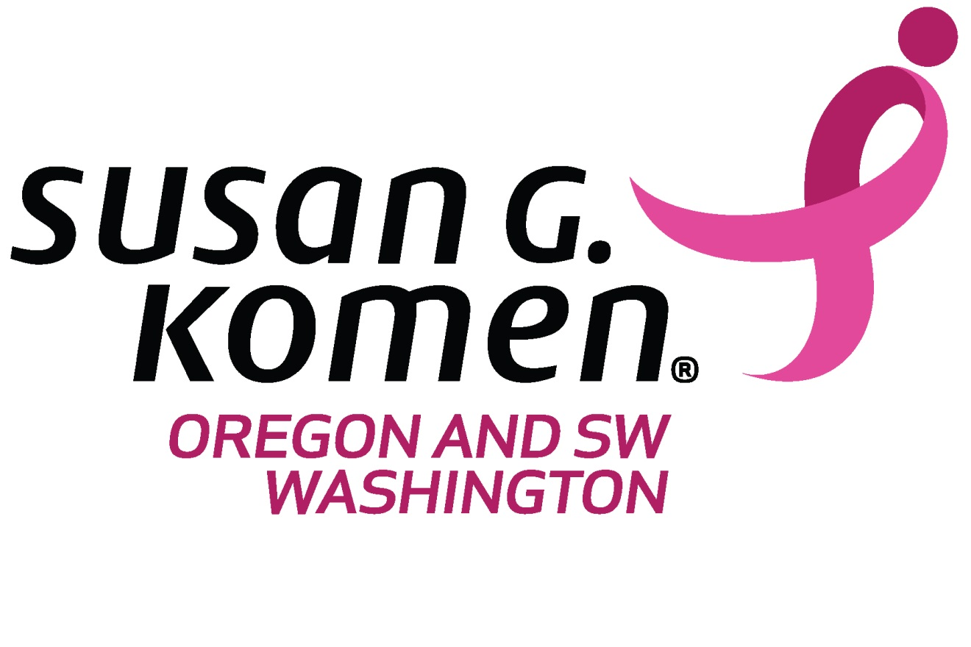
FY19 SMALL GRANTS PROGRAM
REQUEST FOR APPLICATIONS

FOR BREAST HEALTH SUPPORT PROJECTS
PERFORMANCE PERIOD: APRIL 1, 2018 - MARCH 31, 2019

our mission: save lives by meeting the most critical needs IN our communities and investing in breakthrough research to prevent and cure breast cancer

Susan G. Komen ® Oregon & SW Washington
1500 SW 1st Ave, Suite 270
Portland, OR, 97201
Komenoregon.org

Table of Contents

Key Dates 3
About Susan G. Komen® Oregon & SW Washington 3
Notice of Funding Opportunity and Statement of Need 3
Small GrantS Categories 3
Eligibility Requirements 4
Allowable Expenses 5
Important Granting Policies 6
Educational Materials and Messages 7
Review Process 8
Application Instructions 8
Appendix A: FY19 Small Grant Reporting Metrics Error! Bookmark not defined.

Key Dates
Small Grants Applications will be accepted starting April 1, 2018, though January 31, 2019. Applications will be considered at the grants committee meeting following submission. Projects must be completed by March 31, 2019. Limited funding is available and may be distributed prior to the final application submission date. Once funding capacity has been reached, no further applications will be accepted and a notice will be posted on our website, https://komenoregon.org/apply-for-funding/

About Susan G. Komen® Oregon & SW Washington
Susan G. Komen is the world’s largest breast cancer organization, outside of the federal government, funding more breast cancer research than any other nonprofit while providing real-time help to those facing the disease. Komen has set a Bold Goal to reduce the current number of breast cancer deaths by 50 percent in the U.S. by 2026. Since its founding in 1982, Komen has funded more than $956 million in research and provided more than $2.1 billion in funding to screening, education, treatment and psychosocial support programs. Komen has worked in more than 60 countries worldwide. Komen was founded by Nancy G. Brinker, who promised her sister, Susan G. Komen, that she would end the disease that claimed Suzy’s life. Komen Oregon & SW Washington is working to better the lives of those facing breast cancer in the local community. Through events like the Komen Portland and Eugene Race for the Cure®, Komen Oregon & SW Washington has invested $19.5 million in community breast health programs in 39 counties. For more information, call 1.800.404.8241 or visit Komenoregon.org.

Notice of Funding Opportunity and Statement of Need
Komen Oregon & SW Washington is currently offering Small Grants up to no more than $2,000 to support survivors and forever fighters, educational/outreach projects, and/or capacity-building projects as described below, with preference given to communities of color in the Portland Metro area, and Cowlitz, Curry and Linn Counties. For applications seeking funds greater than $2,000 or seeking to provide screening, diagnostic and/or treatment services, please refer to our Community Grants RFA.
The findings from the 2015 Komen Oregon & SW Washington Community Profile revealed that four communities in the service area were at the highest priority for breast health services due to having higher than state average late-stage diagnosis rates. The four target communities include Linn and Curry counties in Oregon, Cowlitz County in SW Washington, and women of color within Clackamas, Multnomah, and Washington counties. The 2015 Community Profile can be found on our website at https://komenoregon.org/grants.

Small Grants Categories
Survivor & Forever Fighter Support Grants
Purpose: To provide support and/or palliative care services to survivors and forever fighters (individuals living with metastatic breast cancer) throughout treatment and survivorship. Support projects must provide a focus on education, increasing treatment compliance/ completion and/or improving healthy lifestyle habits.
Amount: Up to $2,000.
Recognition requirements: Susan G. Komen Oregon & SW Washington must be recognized in all materials.
Educational/Outreach Grants
Purpose: To explore new approaches to reduce breast cancer education barriers identified in Oregon and SW Washington. Education and outreach projects must lead to a documented breast cancer action (e.g., getting a screening mammogram; importance of follow-up after an abnormal mammogram).
Amount: Up to $2,000.
Recognition requirements: Susan G. Komen Oregon & SW Washington must be recognized in all materials.
Conference Grants
Purpose: To support (e.g., logistics; registration fees; presenter fees, etc.) local scientific or educational conferences with presentations/sessions that have an emphasis on the interaction between advocate, public health, health care and scientific communities to address breast cancer disparities to achieve health equity. The presentations/sessions supported by Komen must be focused on breast cancer. (Note: Presenters at a conference cannot be funded through a Komen conference grant and a travel grant.)
Applications for support to attend the Komen Oregon & SW Washington Breast Cancer Issues Conference will not be considered.
Amount: Up to $2,000.
Recognition requirements: Conference organizers must provide complimentary registration for at least two (2) Affiliate representatives and an Affiliate display area where appropriate. In addition, Susan G. Komen Oregon & SW Washington must be recognized in all materials.
Capacity Building Grants
Purpose: To support the development of well-defined projects in Oregon & SW Washington that help build organizational infrastructure to refine/improve skills, strategies or organizational systems that will lead to a decrease in breast cancer disparities to achieve health equity for all.
Amount: Up to $2,000.

Eligibility Requirements
The following eligibility requirements must be met at the time of application submission to apply:

- Individuals are not eligible to apply.
- Applications will only be accepted from governmental organizations under Section 170(c)(1) or nonprofit organizations under Section 501(c)(3) of the Internal Revenue Service (IRS) code. Applicants must prove tax‐exempt status by providing a letter of determination from the IRS.

- Applicant organizations must serve residents in one or more of the following locations:
- Oregon
- SW Washington (Clark, Cowlitz, Skamania Counties)
- Proposed projects must be specific to breast health and/or breast cancer and address the Small Grants Categories listed in this RFA. If a project includes other health issues along with breast cancer, such as a breast and cervical cancer project, funding may only be requested for the breast cancer portion.
- All past and current Komen-funded grants or awards to applicant must be up-to-date and in compliance with Komen requirements. If applicant, or any of its key employees, directors, officers or agents, is convicted of fraud or a crime involving any financial or administrative impropriety in the 12 months prior to the submission deadline for the application, then applicant is not eligible to apply for a grant until 12 months after the conviction. After this 12-month period, applicant must demonstrate in its application that appropriate remedial measures have been taken to ensure that criminal misconduct will not recur.

Allowable Expenses
Funds may be used for the following types of expenses, provided they are directly attributable to the project:
- Key Personnel & Salaries
- Consultants
- Supplies
- Travel
- Other direct project expenses

Funds may not be used for the following purposes:
- Research, defined as any project or program with the primary goal of gathering and analyzing data or information.
  - Specific examples include, but are not limited to, projects or programs designed to:
    - Understand the biology and/or causes of breast cancer
    - Improve existing or develop new screening or diagnostic methods
    - Identify approaches to breast cancer prevention or risk reduction
    - Improve existing or develop new treatments for breast cancer or to overcome treatment resistance, or to understand post‐treatment effects
    - Investigate or validate methods
- Clinical services or patient care costs (e.g. screening, diagnostics, or treatment)
- Indirect Costs
- Education regarding breast self-exams/use of breast models
- Development of educational materials or resources
- Education via mass media (e.g. television, radio, newspapers, billboards), health fairs and material distribution. These methods may be used to promote projects, but evidence-based methods such as 1-1 and group sessions should be used to educate the community and providers
- Construction or renovation of facilities
- Political campaigns or lobbying
- General operating funds
- Debt reduction
- Fundraising (e.g. endowments, annual campaigns, capital campaigns, employee matching gifts, events)
- Event sponsorships
- Projects completed before the date of grant approval
- Land acquisition
- Project-related investments/loans
- Scholarships
- Thermography
- Projects or portions of projects not specifically addressing breast cancer
- Equipment
- Costs related to attendance or participation at the Komen Oregon & SW Washington Breast Cancer Issues Conference

Important Granting Policies
Please note the following non-negotiable policies before submitting an application:
- The project must occur between April 1, 2018 and March 31, 2019.
- The effective date of the grant agreement is the date on which Komen fully executes the grant agreement and shall serve as the start date of the grant. No expenses may be accrued against the grant until the contractual agreement is fully executed. The contracting process can take up to six weeks from the date of the award notification letter.
- Any unspent funds over $1.00 must be returned to Komen Oregon & SW Washington.
- At Komen’s discretion, grant payment will be made in one installment after grant agreement execution or pending receipt and approval of a final report.
- Grantee will be required to submit one final report that will include, among other things, an accounting of expenditures and a description of project achievements. Additional reports may be requested.
- Certain insurance coverage must be demonstrated through a certificate of insurance at the execution of the grant agreement, if awarded. Grantee is required at minimum to hold:
  - Commercial general liability insurance with combined limits of not less than $1,000,000 per occurrence and $2,000,000 in the aggregate for bodily injury, including death, and property damage;
  - Workers’ compensation insurance in the amount required by the law in the state(s) in which its workers are located and employers liability insurance with limits of not less than $1,000,000; and
  - Excess/umbrella insurance with a limit of not less than $3,000,000.
  - In the event any transportation services are provided in connection with project, $1,000,000 combined single limit of automobile liability coverage will be required.
  - Grantees are also required to provide Komen Oregon & SW Washington with a Certificate of Insurance with Susan G. Komen Breast Cancer Foundation, Inc., Susan G. Komen Oregon & SW Washington, its officers, employees and agents named as Additional Insured on the above policies solely with respect to the project and any additional policies and riders entered into by grantee in connection with the project.

Educational Materials and Messages
Susan G. Komen is a source of information about breast health and breast cancer for people all over the world. To reduce confusion and reinforce learning, we only fund projects that use educational messages and materials that are consistent with Komen messages, including our breast self-awareness messages - know your risk, get screened, know what is normal for you and make healthy lifestyle choices. The consistent and repeated use of the same messages can reduce confusion, improve retention and lead to the adoption of actions we believe are important for quality breast care. Please visit the following webpage before completing your application and be sure that your organization can agree to promote these messages:
http://ww5.komen.org/BreastCancer/BreastSelfAwareness.html
Breast Self-Exam must not be taught or endorsed
According to studies, teaching breast self-exam (BSE) has not been shown to be effective at reducing mortality from breast cancer and therefore Komen will not fund education projects that teach or endorse the use of monthly breast self-exams or use breast models. As an evidence-based organization, we do not promote activities that are not supported by scientific evidence or that pose a threat to Komen’s credibility as a reliable source of information on the topic of breast cancer.
Creation and Distribution of Educational Materials and Resources
Komen Affiliate grantees are encouraged to use Komen-developed educational resources, including messages, materials, toolkits or online content during their grant period. This is to ensure that all breast cancer messaging associated with the Komen name or brand are current, safe, accurate, consistent and based on evidence.
In addition, this practice will avoid expenses associated with the duplication of existing educational resources. Grantees can view, download and print all of Komen’s educational materials by visiting http://ww5.komen.org/BreastCancer/KomenEducationalMaterials.html. If a grantee intends to use other supplemental materials, they should be consistent with Komen messages.
Komen materials should be used and displayed whenever possible.
If an organization wants to develop educational resources with Komen grant funds, they must discuss with Komen Oregon & SW Washington prior to submitting an application and provide evidence of need for the resource.
Use of Komen’s Breast Cancer Education Toolkits for Black and African-American Communities and Hispanic/Latino Communities and Other Resources
Komen has developed breast cancer education toolkits for Black and African-American communities and Hispanic/Latino communities. They are designed for educators and organizations to use to meet the needs of these communities. The Hispanic/Latino toolkit is available in both English and Spanish. To access the toolkits, please visit http://komentoolkits.org. Komen has additional educational resources, included on komen.org, that may be used in community outreach and education projects. Check with Komen Oregon & SW Washington for resources that may be used in programming.

Review Process
All applications must be submitted between April 1, 2018 and January 31, 2019.
Each grant application will be reviewed by at the Komen Oregon & SW Washington Grants Committee at the committee meetings on the first Wednesday of every other month. Applicants will be notified of their funding status following this meeting.
The grant application process is competitive, whether or not an organization has received a grant in the past. Funding in subsequent years is never guaranteed and depends upon the quality of this application, the quality of the applicant pool, and the funds available for distribution.

Applicant Support: Questions should be directed to:
Cindy Fletcher
Director of Programs
503-553-3677
Cfletcher@komenoregon.org

Application Instructions
Letters of funding support should be no longer than 2 pages and should be submitted as a PDF. Letters must include the following information:
  - Organization contact information, name of person responsible for overseeing the funding request, and a brief overview of the organization
  - Funding category selected from the Small Grant RFA
  - A statement of need for the project and population to be served
  - An overview of the project design and how it will be implemented
  - An explanation of how the project and outcomes will be monitored and evaluated
  - A description of how Komen will be recognized for the funding
  - Amount of funding requested (up to $2,000) and a budget. Use the Komen approved budget document.
  - In addition to the letter of funding support, include a copy of the organization’s certificate of liability insurance, proof of non-profit status, and W-9.

