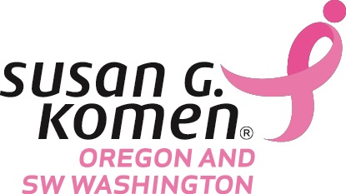
Breast Cancer Issues Conference: General Poster Session Call for Abstracts
The Susan G. Komen Breast Cancer Issues Conference will be held on March 17, 2018 at the DoubleTree Hotel Portland. This conference aims to provide education, support and empowerment for breast cancer survivors, fighters, co-survivors and health professionals. The annual conference covers culturally competent topics such as risk reduction, the latest in research and treatment, and improving quality of life.
Goals of the conference:
- Provide breast cancer survivors and forever fighters with information on advancements in research, treatment and patient care, while providing a space for networking and support.
- Provide a forum for health professionals (nurses, social workers, and imaging technologists) to gather information on the newest research and treatment options while earning continuing education units.
- To provide an opportunity for clinical providers to share best practices in order to provide effective patient centered care.

Please follow the instructions below for submitting your poster abstract:
Abstracts must be submitted by February 9, 2018 to bjamieson@komenoregon.org.
1. Potential Topic Areas:
- Survivorship
- Metastatic breast cancer
- Patient care
- Clinical oncology
- Epidemiology/risks
- Culturally specific care
- Palliative care
- Outcomes and health service research
- Recent breast cancer research developments
- Other
2. Identify authors by full name, credentials and affiliation.
3. Complete every section of the abstract and do not exceed 350 words (not including references).
4. Your abstract must include a summary of data. Abstracts that do not have any data to report will not be accepted.
5. Please submit your file as a .doc file with the primary author’s last name.
a. Ex. Smith_BCI_Abstract_2018.doc
6. Please inform us of how your poster is mounted. We will have poster boards and push pins for presenters unless otherwise requested.
_______________________________________________________________________________________________________

CONTINUE TO NEXT PAGE

2018 Breast Cancer Issues Conference Abstract Template

Primary Author Name, Credentials, Affiliation:

Co-Author(s) Name(s), Credentials, Affiliation(s):

Topic Area:

Title:

Background:

Methods:

Results:

Conclusions:

The BCI Planning Committee reserves the right to accept or refuse an abstract. Abstracts will be reviewed and the authors will be notified by email by February 23, 2018. Please contact Bridget Jamieson, Community Programs Manager, with any questions at
503-546-7445 or at Bjamieson@komenoregon.org

